**CIS1360 – Week 13 Assignment 2**

|  |  |
| --- | --- |
| **Date:** | **December 5, 2014** |
| **To:** | **Mike MacDonald** |
| **From:** | **Christopher Sigouin** |
| **Subject:** | **Research an Internet Access Technology** |

______________________________________________________________________________

This exercise was to research an internet access technology of our own choosing. I opted to go with “Satellite “access specifically through Xplornet. As I am not familiar with this type of technology, I believe it was a good research opportunity.

Xplornet boasts a combination of two types of networks that allow for 100% of all Canadians to be able to aquire broadband internet access. One consisting of two 4G satellites named ViaSat-1 and Jupiter1 (also called EchoStar XVII). Both satellites hold a geostationary orbit to cover most of the southern portion of Canada. The more northern parts including other remote areas, are covered by a fixed 4G wireless network consisting of 380 towers. They state that it uses the LTE standard and is upgradable so I suppose it is not actually 4G unless they are using LTE Advanced now. Both satellites are said to utilize the Ka-band spectrum allowing for more bandwidth and throughput to customers. “Ka-band” is part of the microwave band (K-band) electromagnetic spectrum that ranges from 26.5 to 40GHz. Below is a picture of the different bands of the spectrum:

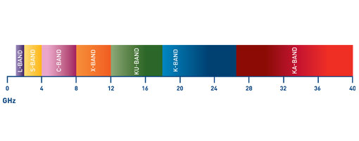

REF: http://www.newsat.com/Satellites/ka 1

A fair access policy is implemented so that users who are constantly using the bandwidth do not affect other customers utilizing the service. It is different for each type of technology provided by Xplornet. These are a few of the items that can occur without going into major details for each platform:

* + Specific times during the day are considered “peak“ hours where policies apply
  + Customer are placed into a “Recovery Mode” where usage is reduced to 50% of their package speed if they use more than 4GB in the 24 hour period
  + If network congestion is detected their system finds the top 10% of heavy users and halves their maximum speed for 15 minutes. If it continues it will repeat the process again

**Advantages**

* Can support many customers who do not have access to standard forms of broadband internet access (i.e. DSL, Cable, etc.)
* More resistant to weather related issues than standard forms of internet.
* Less infrastructure can be affected by potential damaging effects

**Disadvantages**

* Slow communications due to latency issues with communications from ground tower to satellite
* VOIP does not work efficiently with the architecture
* Equipment repair times may be slower than repair times for standard broadband services

**Costs / Plans**

|  |  |  |  |
| --- | --- | --- | --- |
|  | **STARTER** | **SHARE** | **STREAM** |
| **Pricing** | $44.99 | $64.99 | $84.99 |
| **Install Fee** | FREE | FREE | FREE |
| **Activation Fee** | $99 | $99 | $99 |
| **Download Speed ( *up to* )** | 1.5Mbps | 5.0Mbps | 10.0Mbps |
| **Upload Speed ( *up to* )** | 700kbps | 1.0Mbps | 1.0Mbps |
| **Monthly Usage Allowance** | 5GB | 20GB | 20GB |
| **Additional Usage** | N/A | 10GB / $5 a month  20GB / $10 a month | 10GB / $5 a month  20GB / $10 a month |
| **IP Addressing** | Dynamic | Dynamic | Dynamic |

**Availability**

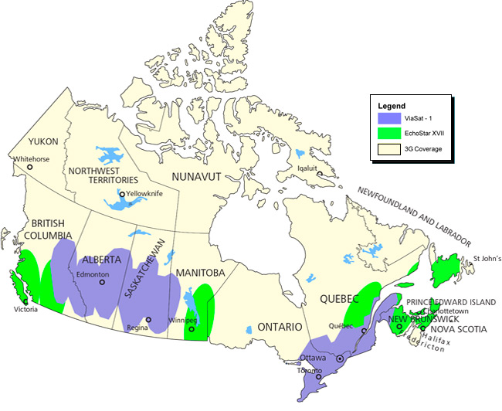The coverage for Canada is listed on the left as you can see. Both satellites cover most of the southern portion of Canada as mentioned. The more northern parts have access only to the 3G coverage (they stated 4G but this may be an old image). PEI would have access to the newest Jupiter satellite.[1]

1. REF IMAGE: http://www.xplornet.com/how-it-works/national-4g-satellite-coverage/